DATABASE MANAGEMENT LAB
LAB Assignments
Submitted in partial fulfilment of the requirement of the degree of
BACHELORS OF TECHNOLOGY
to
K.R Mangalam University



Submitted by: Submitted to
Utkarsh Singh Ms. Mansi Kajal
(2401010099)

Department of Computer Science and Engineering
School of Engineering and Technology
K.R Mangalam University, Gurugram- 122001, India
Batch – 2024-2028

Experiment : 1
Question 1. Consider following databases and draw ER diagram and convert entities
and relationships to relation table for a given scenario:
COLLEGE DATABASE
STUDENT (USN, SName, Address, Phone, Gender)
SEMSEC (SSID, Sem, Sec)
CLASS (USN, SSID)
SUBJECT (Subcode, Title, Sem, Credits)
IAMARKS (USN, Subcode, SSID, Test1, Test2, Test3, FinalIA)
Solution:
- The entities STUDENT, SEMSEC, SUBJECT, and IAMARKS are identified and represented using rectangles.
- The attributes are represented using ellipses:
# STUDENT: USN (Primary Key), SName, Address, Phone, Gender
- USN is underlined as it is the Primary Key.
- Phone is shown as a single-valued attribute.
# SEMSEC: SSID (Primary Key), Sem, Sec
- SSID is underlined as the Primary Key.
# SUBJECT: Subcode (Primary Key), Title, Sem, Credits
- Subcode is underlined as the Primary Key.
# IAMARKS: USN, Subcode, SSID, Test1, Test2, Test3, FinalIA
- USN, Subcode, and SSID together form a composite key.
- Test1, Test2, Test3, and FinalIA are normal attributes.
- Primary keys are represented by underlining the attribute names.
- CLASS is drawn as a relationship (diamond shape) between STUDENT and SEMSEC.
- The relationship between STUDENT and SEMSEC through CLASS is M : 1, meaning many students belong to one semester and section.
- The M : N relationship between STUDENT and SUBJECT is resolved using the associative entity IAMARKS.
- The relationship STUDENT – IAMARKS is 1 : M, indicating one student can have multiple internal assessment records.
- The relationship SUBJECT – IAMARKS is 1 : M, indicating one subject can have multiple IA records for different students.
- The relationship SEMSEC – IAMARKS is 1 : M, showing that marks are maintained semester-section wise.
- All entities, attributes, relationships, primary keys, foreign keys, and cardinalities are clearly represented in the ER diagram.
ER DIAGRAM:

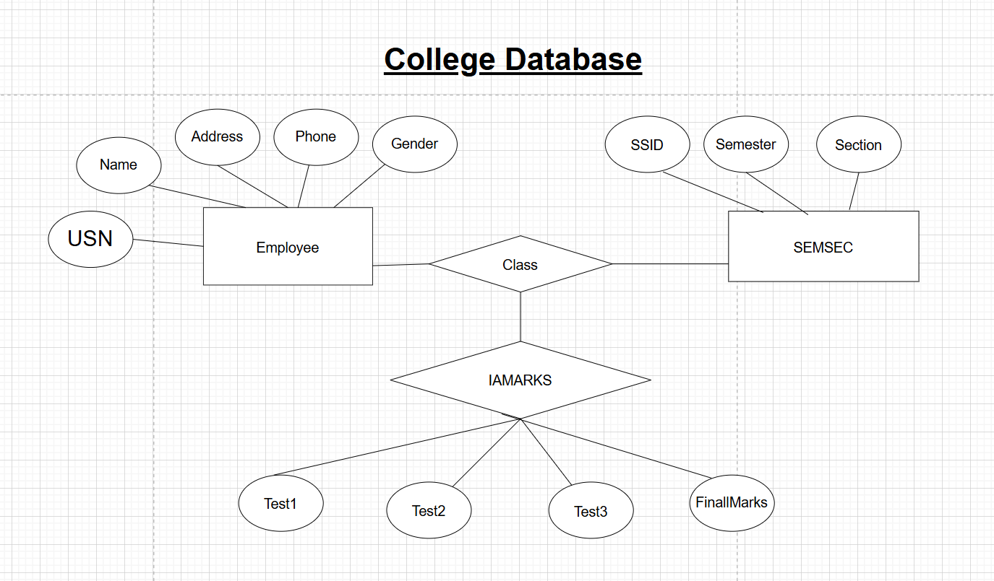

Experiment : 2
Question 2. Consider following databases and draw ER diagram and convert entities
and relationships to relation table for a given scenario:
COMPANY DATABASE
EMPLOYEE (SSN, Name, Address, Salary, Sex, SuperSSN, DNO)
DEPARTMENT (DNo, DName, MgrSSN, MgrStartDate)
PROJECT (PNo, PName, PLocation, DNO)
DLOCATION (DNo, DLoc)
WORKS_ON (SSN, PNo, Hours)
MANAGES (SSN, DNo)
Solution:
- The entities EMPLOYEE, DEPARTMENT, PROJECT, and DLOCATION are identified and represented using rectangles.
- The attributes are represented using ellipses:
# EMPLOYEE: SSN (Primary Key), Name, Address, Salary, Sex, SuperSSN, DNO
- SSN is underlined as it is the Primary Key.
- SuperSSN is a foreign key referencing EMPLOYEE (self-relationship).
- DNO is a foreign key referencing DEPARTMENT.
# DEPARTMENT: DNo (Primary Key), DName, MgrSSN, MgrStartDate
- DNo is underlined as the Primary Key.
- MgrSSN is a foreign key referencing EMPLOYEE.
# PROJECT: PNo (Primary Key), PName, PLocation, DNO
- PNo is underlined as the Primary Key.
- DNO is a foreign key referencing DEPARTMENT.
# DLOCATION: DNo, DLoc
- DNo and DLoc together form a composite key.
- DNo is a foreign key referencing DEPARTMENT.
# WORKS_ON: SSN, PNo, Hours
- SSN and PNo together form a composite key.
- Hours is a descriptive attribute of the relationship.
- Primary keys are represented by underlining the attribute names.
- The relationship WORKS_ON is drawn as a diamond between EMPLOYEE and PROJECT with M : N cardinality, indicating that:
  - One employee can work on many projects.
  - One project can have many employees.
  - Hours attribute represents the number of hours worked.
- The relationship MANAGES is drawn between EMPLOYEE and DEPARTMENT with 1 : 1 cardinality, indicating:
  - One employee manages one department.
  - Each department has one manager.
- The relationship between EMPLOYEE and DEPARTMENT (via DNO) is M : 1, meaning:
  - Many employees work in one department.
- The relationship between DEPARTMENT and PROJECT is 1 : M, meaning:
  - One department controls many projects.
  - Each project belongs to one department.
- The relationship between DEPARTMENT and DLOCATION is 1 : M, meaning:
  - One department can have multiple locations.
- A recursive relationship exists in EMPLOYEE through SuperSSN, representing that:
  - One employee can supervise many employees.
- All entities, attributes, relationships, primary keys, foreign keys, and cardinalities are clearly represented in the ER diagram.
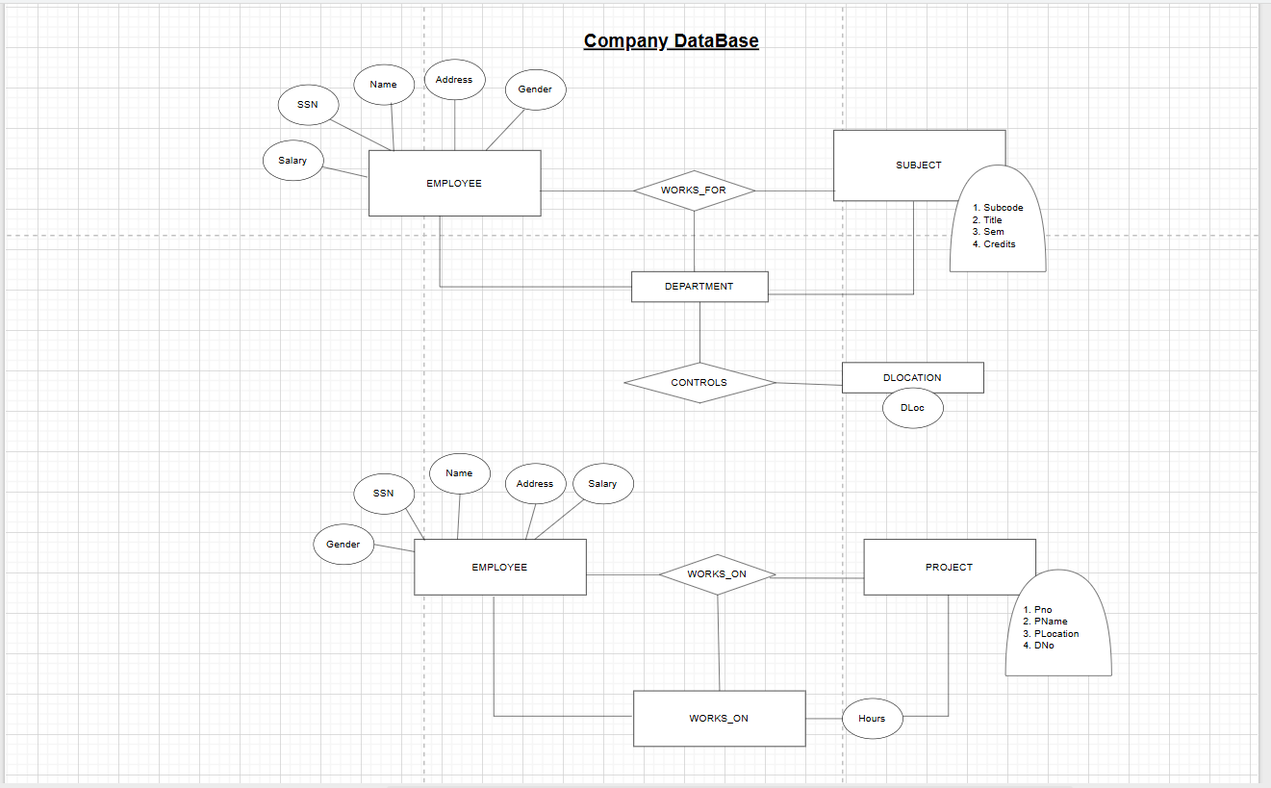
ER DIAGRAM:
Experiment : 3
Question : Database Schema for a customer-sale scenario
Customer(Cust id : integer, cust_name: string)
Item(item_id: integer, item_name: string, price: integer)
Sale(bill_no:integer,bill_data:date,cust_id: integer, item_id: integer, qty_sold: integer)
For the above schema, perform the following—
1. Create the tables with the appropriate integrity constraints.
Code:

CREATE DATABASE IF NOT EXISTS CustomersSaleDB;
USE CustomersSaleDB;

CREATE TABLE IF NOT EXISTS Customer (
cust_id INT PRIMARY KEY,
cust_name VARCHAR(100) NOT NULL
);

CREATE TABLE IF NOT EXISTS Item (
item_id INT PRIMARY KEY,
item_name VARCHAR(100) NOT NULL,
price INT NOT NULL,
CHECK (price > 0)
);

CREATE TABLE IF NOT EXISTS Sale (
bill_no INT,
bill_date DATE NOT NULL,
cust_id INT,
item_id INT,
qty_sold INT NOT NULL,
CHECK (qty_sold > 0),
PRIMARY KEY (bill_no, item_id),
FOREIGN KEY (cust_id) REFERENCES Customer(cust_id)
ON DELETE CASCADE
ON UPDATE CASCADE,
FOREIGN KEY (item_id) REFERENCES Item(item_id)
ON DELETE CASCADE
ON UPDATE CASCADE
);

INSERT INTO Customer VALUES
(1,'Utkarsh'),
(2,'Rahul'),
(3,'Sneha'),
(4,'Amit'),
(5,'Priya'),
(6,'Karan'),
(7,'Neha'),
(8,'Rohit'),
(9,'Simran'),
(10,'Vikas');

INSERT INTO Item VALUES
(101,'Laptop',50000),
(102,'Mouse',500),
(103,'Keyboard',800),
(104,'Monitor',12000),
(105,'USB Cable',200),
(106,'Headphones',1500),
(107,'Charger',900),
(108,'Tablet',25000),
(109,'Smartphone',30000),
(110,'Pen Drive',700);

INSERT INTO Sale VALUES
(1001,CURDATE(),1,101,1),
(1002,CURDATE(),2,102,2),
(1003,CURDATE(),3,104,1),
(1004,CURDATE(),4,105,3),
(1005,CURDATE(),5,108,1),
(1006,CURDATE(),6,110,4),
(1007,CURDATE(),7,103,2),
(1008,CURDATE(),8,109,1),
(1009,CURDATE(),9,106,1),
(1010,CURDATE(),10,107,2);

SELECT s.bill_no, c.cust_name, s.item_id
FROM Sale s
JOIN Customer c ON s.cust_id = c.cust_id
WHERE s.bill_date = CURDATE();

SELECT
s.bill_no,
s.qty_sold,
i.price,
(s.qty_sold * i.price) AS final_amount
FROM Sale s
JOIN Item i ON s.item_id = i.item_id;

SELECT DISTINCT c.cust_id, c.cust_name
FROM Customer c
JOIN Sale s ON c.cust_id = s.cust_id
JOIN Item i ON s.item_id = i.item_id
WHERE i.price > 200;

SELECT
c.cust_id,
c.cust_name,
SUM(s.qty_sold) AS total_products_bought
FROM Customer c
JOIN Sale s ON c.cust_id = s.cust_id
GROUP BY c.cust_id, c.cust_name;

SELECT i.item_id, i.item_name
FROM Sale s
JOIN Item i ON s.item_id = i.item_id
WHERE s.cust_id = 5;

SELECT DISTINCT i.*
FROM Item i
JOIN Sale s ON i.item_id = s.item_id
WHERE s.bill_date = CURDATE();

CREATE OR REPLACE VIEW Bill_View AS
SELECT
s.bill_no,
s.bill_date,
s.cust_id,
s.item_id,
i.price,
s.qty_sold,
(s.qty_sold * i.price) AS amount
FROM Sale s
JOIN Item i ON s.item_id = i.item_id;

SELECT * FROM Bill_View;

CREATE OR REPLACE VIEW Weekly_Sales AS
SELECT
s.bill_date,
SUM(s.qty_sold * i.price) AS total_sales
FROM Sale s
JOIN Item i ON s.item_id = i.item_id
WHERE s.bill_date >= CURDATE() - INTERVAL 7 DAY
GROUP BY s.bill_date;

SELECT * FROM Weekly_Sales;

Outputs:
1.
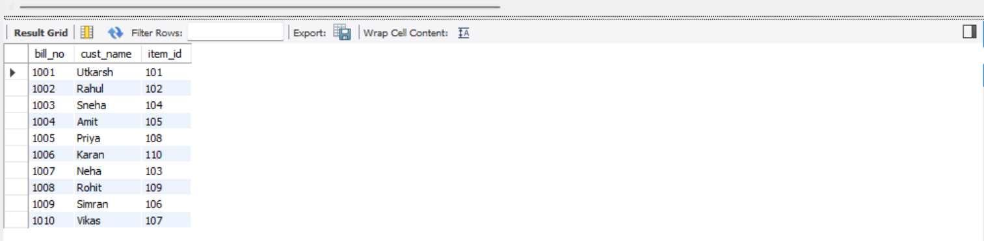
2.
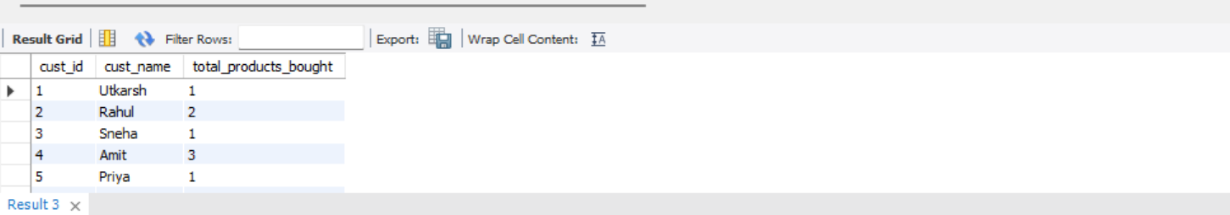
3.
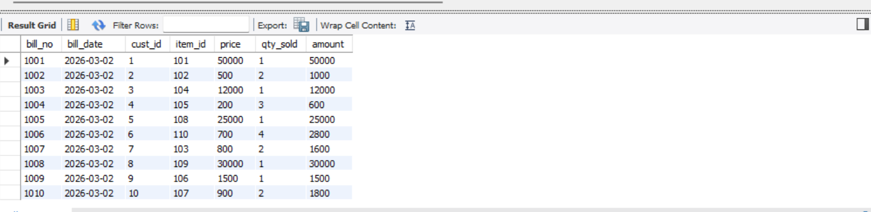
4.
